2.6 Creating reusable (Power BI) assets

Key points

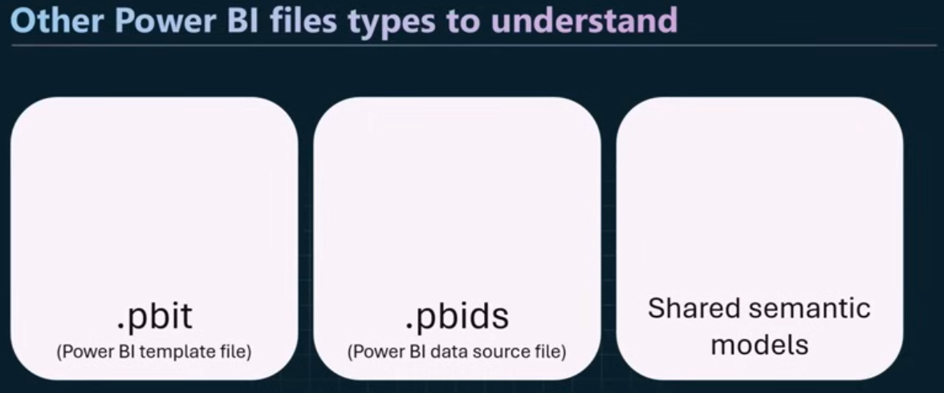
Power BI template file (.pbit):
- The .pbit file is a Power BI template. It is a reusable asset which can improve efficiency and consistency when creating Power BI reports.

- You can easily save a pbix file as a Power BI template file, then you can generate a new report from that template (you will be asked to input parameter values, if there are any in the report, when creating the new report).

- To create a Power BI template file (.pbit): it can be done on Power BI desktop while saving choose format as .pbit and you can also give it a description.
Power BI data source file (.pbids)
- In Power BI Desktop, if you go to Data Source settings, you can export a .pbids file which documents all the data source connections that have been configured in your project. This can then be re-used in another report.
Shared semantic models:
- Sharing semantic models enables the re-use of models for different use cases. With the benefit that a single model can be managed and maintained, but this model might be consumed by multiple reports, dashboards and/ or Excel workbooks.

